Weston on the Green Parish Tree Audit
- The Spinney, Jubilee Playing Field
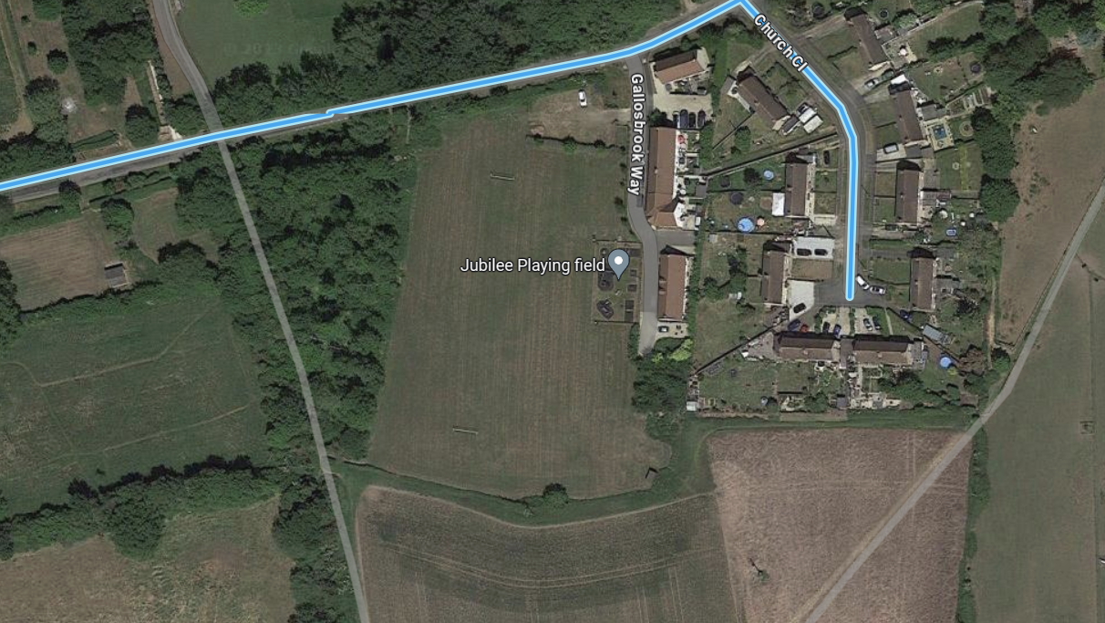

2. The Stocks, triangle of land bounded by B430 & Church Road – x2 trees

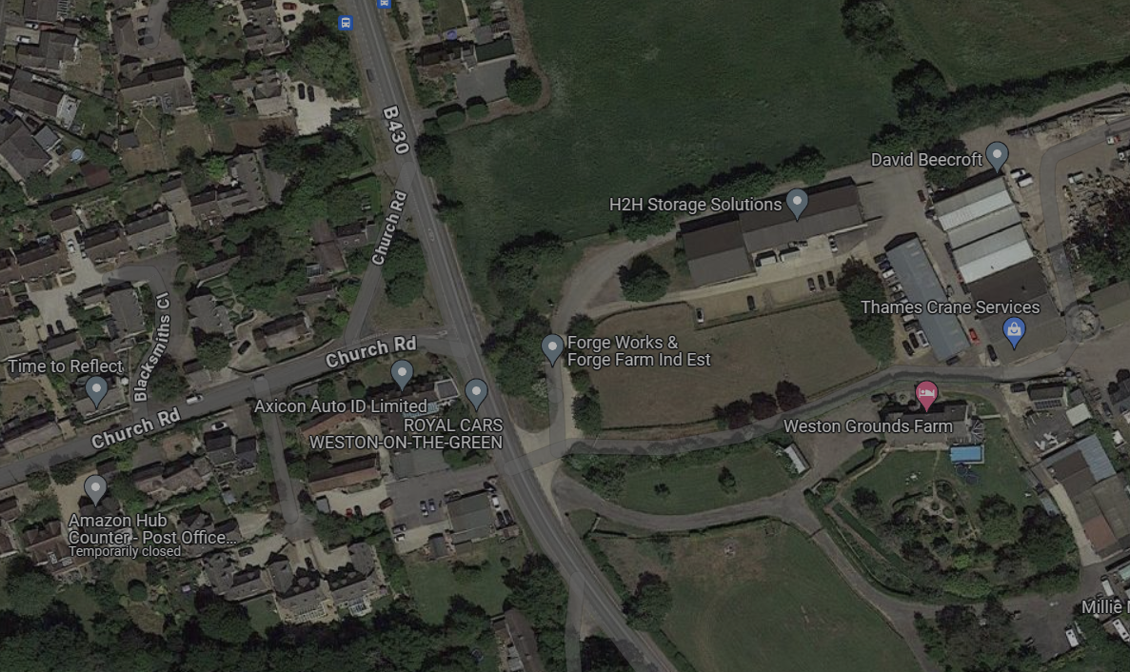

- Trees at back of pond, middle of North Lane
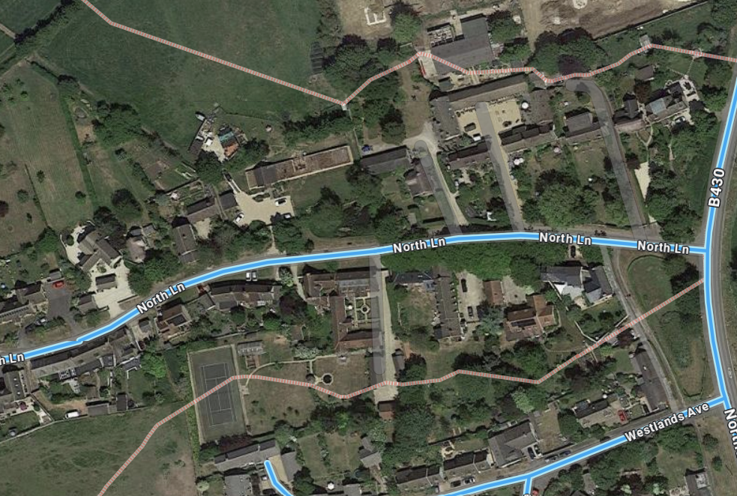

- Willow tree, rear of pond at corner of North Lane & B430 (in front of Oak View house)
